SOLISTEN® ELMA Quick Start Guide
9- RESET
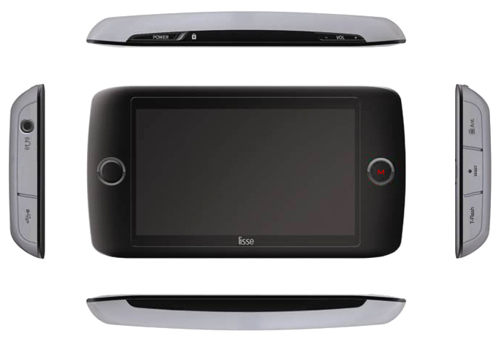

5-Headphone output
6-Loudspeaker
2-Volume (+,-), Left and Right direction
4- Touch
LCD screen
8- T-flash card
input

The instructions contained in this manual will help you understand the main functions of the SOLISTEN LISSE®. Please read this manual carefully before the first use.

7-USB
1-On/Off
Lock
DESCRIPTION OF THE OPERATING BUTTONS:

3- ENTER &
Alternative operation

- On/Off/Lock:

Switch the device on/off by pushing this button to the left for two seconds. By pushing it to the right, it locks all the operating buttons to avoid unintentional operations such as unexpected switching on/off of the device. Use the lock operation after you choose the correct music piece or before turning off the device. It is recommended to lock the functions during listening sessions.

2- Volume (+,-), Left & right, up & down direction:

Punch the (+) to increase the volume, punch the (-) to decrease the volume. You may access the menu items by pushing these buttons up and down.
Caution: Lengthy listening at a high volume can damage your hearing.

3-Alternative operation:

You may press this button to manage your program instead of using the touch screen. Combined with the button +/-, left & right, it allows all navigation operations as an alternative to using the touch screen. By maintaining the pressure, this button gives you the possibility to return to the previous screen.

4- LCD touch screen:

You locate and use the different menus and functions of the device by touching the LCD screen. With your finger, press on the object or desired action to select it and a second time to choose it.

5- Headphone output:

With the mini-jack connector you plug the headphone to the device.

6- Loudspeaker:

When no headphone is plugged to the device, the sound comes out through the loudspeaker. It automatically stops when you insert the mini-jack in the headphone plug.

7- USB plug:

This plug connects the device to a computer and provides a way to down or upload files.

8- T-Flash card input:

The memory of this device can be extended thanks to the addition of a T-Flash card in this card slot.

9- RESET

By using a dull tip (such as a paper clip) pushed in this hole, all settings (clock, date, language, etc.) are erased without erasing the content (music, programs etc.). The RESET function has to be used when some functions of the device are blocked.

The belt
This device is created to withstand a variety of use. However, we ask you to use the belt we provide for protection of the device. Your warranty does not cover abusive use such as throwing it on the ground, hard surfaces, dropping in water, purposefully harming it with physical force to make it work, pulling at the headphones, jumping on it, throwing it around, or any type of use that is not considered professional use of this device. Please inquire if you have questions about your warranty.

ACCESSING TO THE PROGRAMS AND LISTENING TO THE MUSIC

- MAIN MENU

The main menu gives the functions of the multimedia player: MUSIC, VIDEO, E-BOOK, SYSTEM.
Select MUSIC.
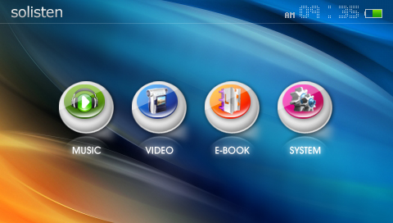

- MENU « MUSIC »

The « MUSIC » menu gives access to the following functions:
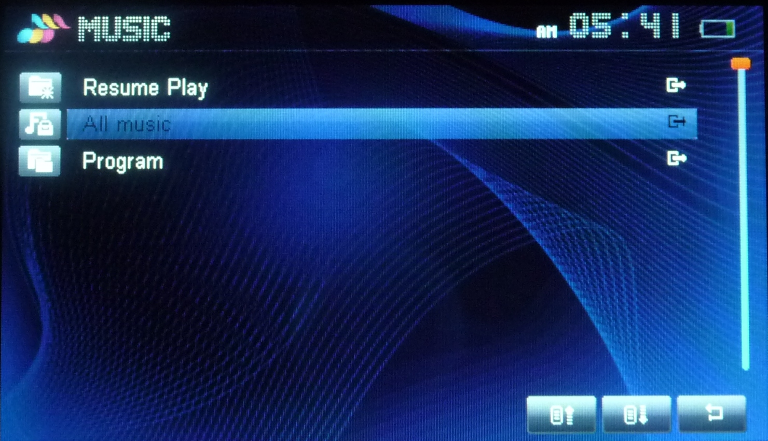

-Resume Play/Current play / music reading shows the piece of music running on the device (if music is playing).
-All Music shows all the music pieces recorded on the device.
-Program / directory accesses the list of programs recorded on the device.

- « PROGRAM

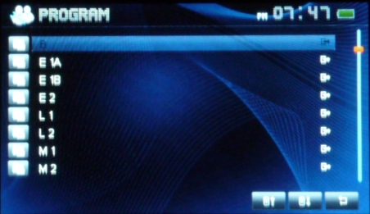

In the list of 8 programs recorded on the device, select the one assigned to take.

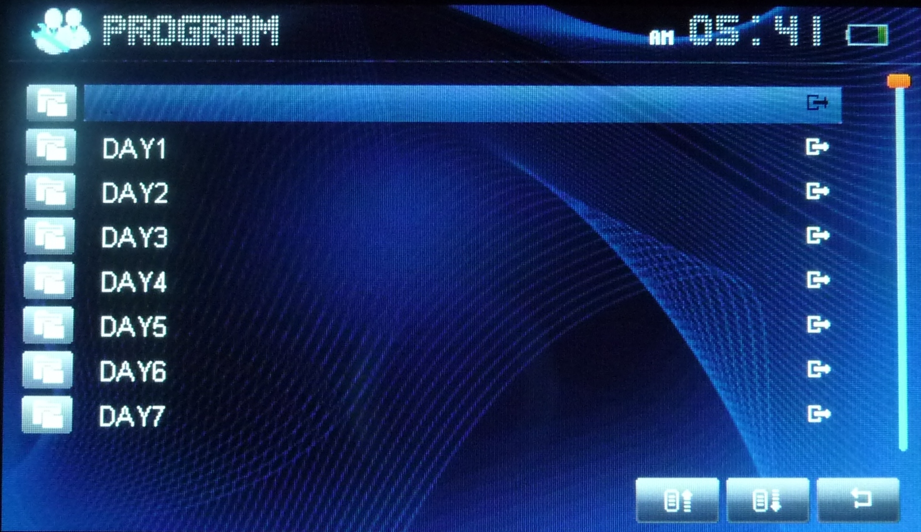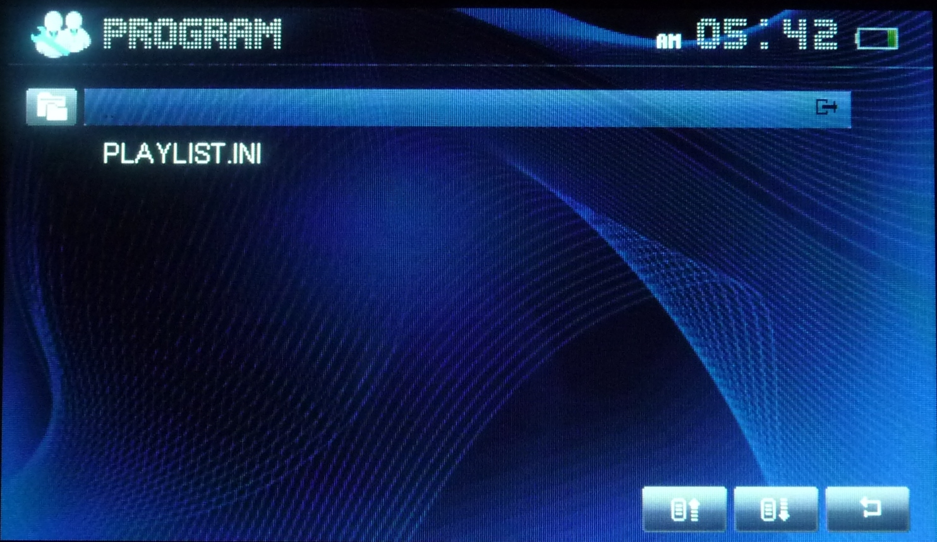

Among the fifteen recorded days in each program, select the Day you are on, then the line « PLAYLIST.INI »

Select the one corresponding to the current position in the session (i.e. program).
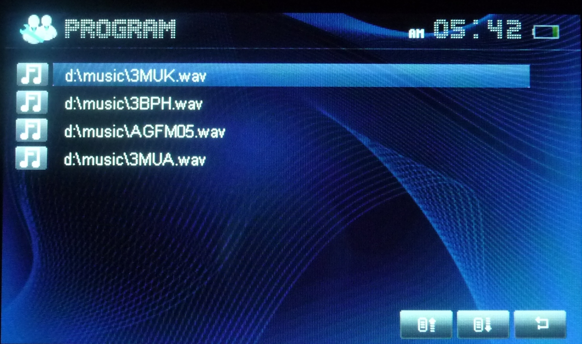

4- READING

This window accesses information about the current listening session (name of piece of music, timing, position in the session…). It also gives you some settings.
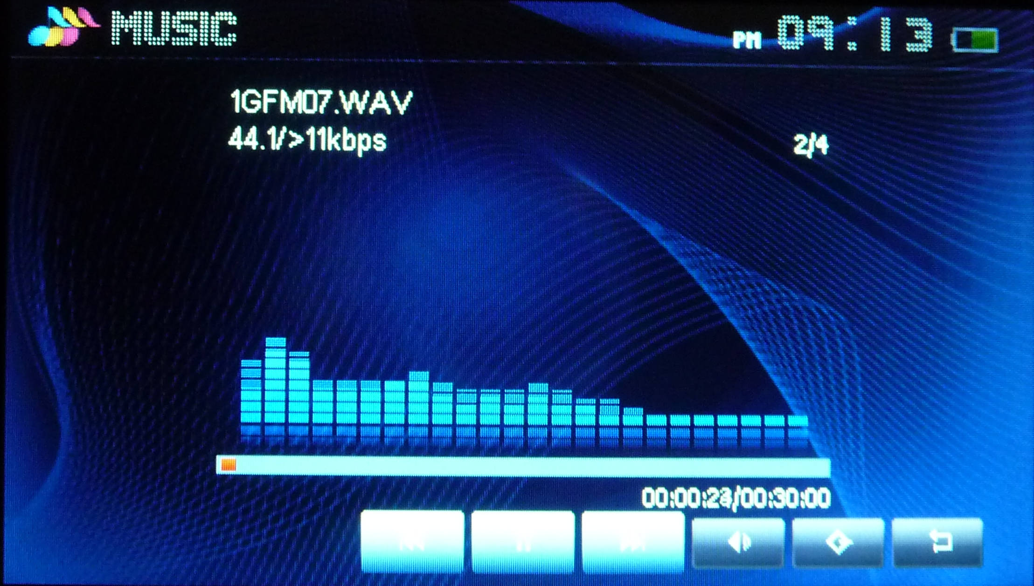

The specific settings such as « reading mode », repetition …, should not be modified and the reading toolbar should always appear on the screen as below:

As a rule, these settings show the order of music pieces for one programmed day. Once the first piece begins, the device will play all 4 half-hour pieces in progression. You may pause during your session by pressing the pause button (II).

The icon adjusts the volume by touching the screen.
The icon accesses advanced reading settings (see user manual)

Reminder: It is recommended to lock the controls during listening.

ELECTRIC CHARGE

The electric charge has to be completed thanks to the power supply provided with the device. For a more longevity of the battery, we advise you to use as much as possible the charge before fully recharging the battery (full charge =+/-6 hours). During the charge, the following screen appears:
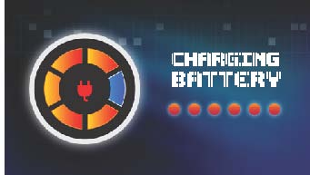

If the device is manipulated, this screen is replaced by the general menu where a green battery icon (up right on the screen) allows to check the progress of the charge. To make the battery screen come back, you just have to use the « off » button as if you wanted to turn off the device. Do not disconnect the device as long as the battery screen and the green icon vary.

